**DAILY ONLINE ACTIVITIES SUMMARY**

|  |  |  |  |  |  |  |  |  |
| --- | --- | --- | --- | --- | --- | --- | --- | --- |
| **Date:** | **18/5/2020** | | | | | **Name:** | **Manoj L** | |
| **Sem & Sec** | **8th Sem** | | | | | **USN:** | **4AL16CS125** | |
| **Online Test Summary** | | | | | | | | |
| **Subject** | | SMS: Random number generation | | | | | | |
| **Max. Marks** | | **60** | | **Score** | | | 40 | |
| **Certification Course Summary** | | | | | | | | |
| **Course** | **Data Science & Machine Learning Bootcamp** | | | | | | | |
| **Certificate Provider** | | | Udamy | | **Duration** | | | 42 hrs |
| **Coding Challenges** | | | | | | | | |
| **Problem Statement:**  1:Using methods charAt() & length() of string class.  2:Print even and odd numbers series respectively from two threads t1 and t2. | | | | | | | | |
| **Status:COMPLETED** | | | | | | | | |
| **Uploaded the report in Github** | | | | | **yes** | | | |
| **If yes Repository name** | | | | | **Manoj_L** | | | |
| **Uploaded the report in slack** | | | | | **yes** | | | |

Online Test Details: (Attach the snapshot and briefly write the report for the same)

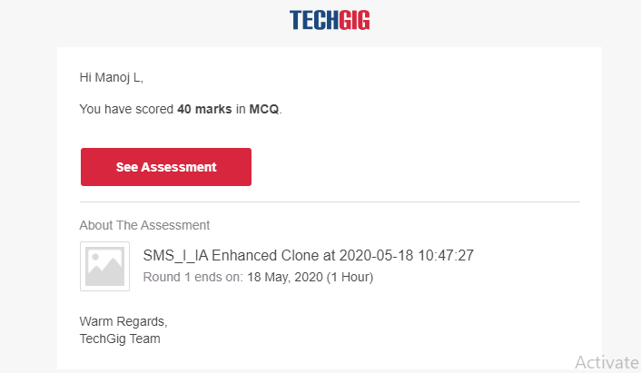

Certification Course Details: (Attach the snapshot and briefly write the report for the same) 